Aim: To obtain the best fit line over single feature scattered datapoints using Linear Regression
IDE: Google Colab

Theory:

Linear regression is a method for determining the best linear relationship between two variables X and Y. If variables X and Y are uncorrelated, it is pointless embarking upon linear regression. However, if a reasonable degree of correlation exists between X and Y then linear regression may be a useful means to describe the relationship between the two variables. The usual approach is to use the least-squares method, which minimizes the squared difference between the actual data points and a straight line. Let [x_{i},y_{i}], i = 1,2,3,….,N be the N pairs of data values of the variables X and Y. The straight-line relating X and Y is y = mx + c, where m and c are the gradient and constant values (to be determined) defining the straight line. Thus, y(x_{i}) - y_{i} is the difference between the line and data point i (see Fig. 1). Taking all the data points, we seek values of m and c that minimize the squared difference SD.
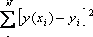

This is achieved by calculating the partial derivatives of SD with respect to m and c and finding the pair [m,c] such that SD is at a minimum.
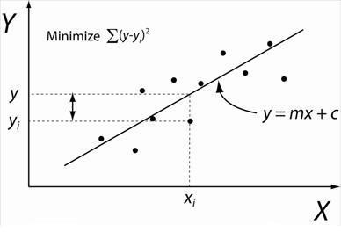

Figure 1: Illustration of Linear Regression. Linear least squares regression, the idea is to find the line y = mx + c that minimizes the mean squared difference between the line and the data points

Batch Gradient Descent:
Gradient Descent is an optimization algorithm used for minimizing the cost function in various machine learning algorithms. It is basically used for updating the parameters of the learning model. Batch gradient descent which processes all the training examples for each iteration of gradient descent. But if the number of training examples is large, then batch gradient descent is computationally very expensive.
Let m be the number of training examples. Let n be the number of features.

Algorithm for batch gradient descent :
Let h_{θ}(x) be the hypothesis for linear regression. Then, the cost function is given by:
Let Σ represents the sum of all training examples from i=1 to m.
J_{train}(θ) = (1/2m) Σ( h_{θ}(x^{(i)}) - y^{(i)})²
Repeat {
θj = θj – (learning rate/m) * Σ( h_{θ}(x^{(i)}) - y^{(i)})x_{j}^{(i)}
For every j =0 …n
}
Where x_{j}^{(i)} Represents the j^{th} feature of the i^{th} training example. So if m is very large(e.g. 5 million training samples), then it takes hours or even days to converge to the global minimum.That’s why for large datasets, it is not recommended to use batch gradient descent as it slows down the learning.

Pre Lab Exercise:
- Explain the meaning of linear regression
Linear regression is a method used to find the relationship between two variables.It fits a straight line (y = mx + c) to the data.It is used to predict the output based on input values.

- Write three applications of linear regression
House price prediction, Sales forecasting, Stock price prediction

- Write three advantages of linear regression
Simple and easy to implement, Easy to interpret results, Works well with small datasets

- Write three limitations of linear regression
Assumes linear relationship between variables, Sensitive to outliers, Cannot handle complex relationships

Methodology:
- Load the basic libraries and packages
- Load the dataset
- Analyse the dataset
- Pre-process the data
- Visualize the Data
- Separate the feature and prediction value columns
- Write the Hypothesis Function
- Write the Cost Function
- Write the Gradient Descent optimization algorithm
- Apply the training over the dataset to minimize the loss
- Find the best fit line to the given dataset
- Observe the cost function vs iterations learning curve

import matplotlib.pyplot as plt
import pandas as pd
import numpy as np

dataset=pd.read_csv("/content/exp-1_train.csv")
dataset
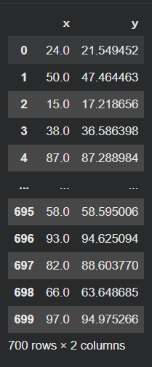
dataset.describe()
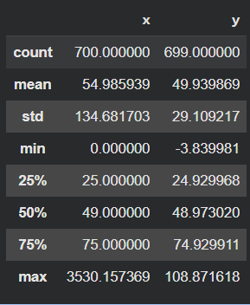

x=dataset.iloc[0:700,0:1]
y=dataset.iloc[0:700,1:2]
x.boxplot()
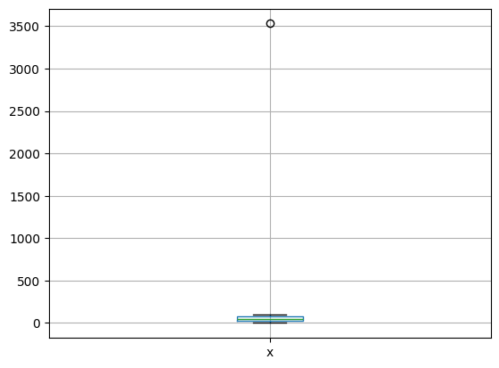
y.boxplot()
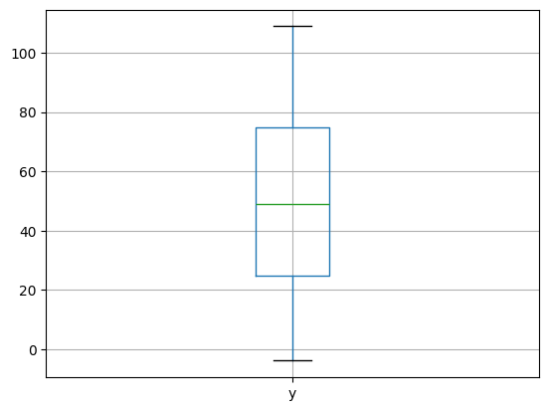
#plot the scatter plot
plt.scatter(x,y)
plt.xlabel('x')
plt.xlabel('y')
plt.title("X vs Y Scatter Plot")
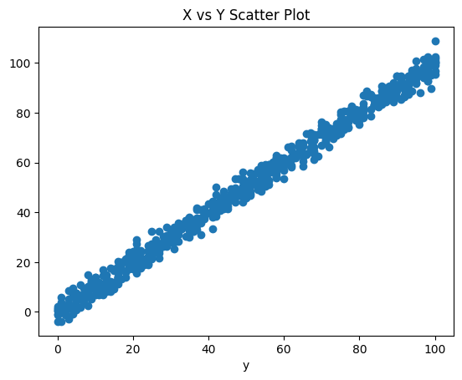
#Linear Regression
def hypothesis(theta_array,x):
return theta_array[0]+theta_array[1]*x

def cost_function(theta_array,x,y,m):
error=0
for i in range(m):
error=error+((theta_array[0]+theta_array[1]*x)-y[i])**2
return error/(2*m)

def gradint_descent(theta_array,x,y,m,alpha):
summation_0=0
summation_1=0

for i in range(m):
summation_0+=(theta_array[0]+theta_array[1]*x[i])-y[i]
summation_1+=x[i]*((theta_array[0]+theta_array[1]*x[i])-y[i])

new_theta0=theta_array[0] - (alpha/m) * summation_0
new_theta1=theta_array[1] - (alpha/m) * summation_1
updated_new_theta=[new_theta0,new_theta1]
return updated_new_theta

def training(x,y,alpha,iters):
theta0=0
theta1=0
cost_values=[]
theta_array=[theta0,theta1]
m=x.size

for i in range(iters):
theta_array=gradint_descent(theta_array,x,y,m,alpha)
cost_values.append(cost_function(theta_array,x,y,m))
y_predict=x*theta_array[1]+theta_array[0]
plt.plot(y_predict,x,'r')
plt.scatter(x,y)
plt.show()
return cost_values,theta_array

#Fidding the input data
training_data=dataset.dropna()

training_data.shape
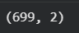

x_value=training_data['x']
y_value=training_data['y']
type(x_value)

x_value=x_value.values.reshape(x_value.size)
y_value=y_value.values.reshape(y_value.size)
type(x_value)

alpha=0.0001
iters=50
cost_values,theta_array=training(x_value,y_value,alpha,iters)
First Iteration:
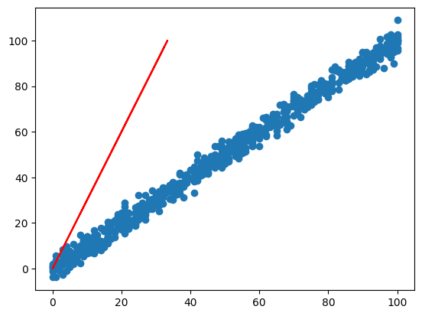

Last Iteration:
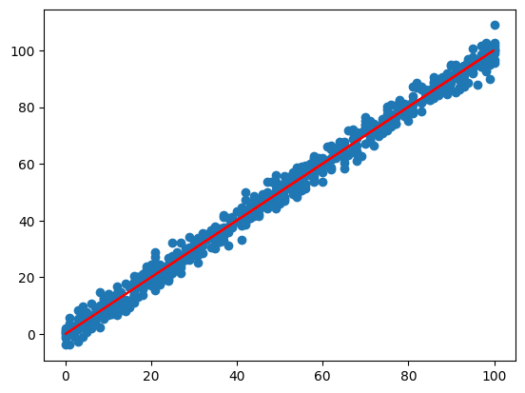

x_axis=np.arange(0,len(cost_values),step=1)
plt.plot(x_axis,cost_values)
plt.xlabel("Iterations")
plt.ylabel("Cost_values")
plt.title("Loss Graph")
plt.show()
print(theta_array)
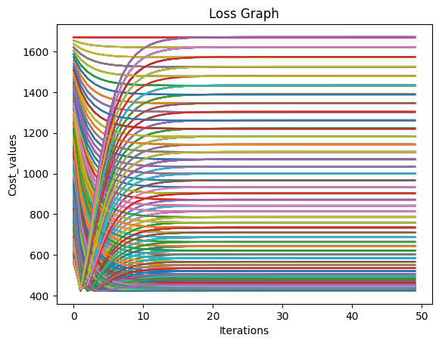

hypothesis(theta_array,25.0)
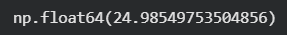

Observation and Result Analysis:
- Nature of the dataset
The dataset contains two variables x and y.It is a numerical dataset.The data shows a linear relationship between x and y.
- During Training Process
During training, gradient descent updates the values of theta.The cost function decreases with each iteration.The model gradually learns the best fit line.
- After the training Process

After training, the model finds the best values of theta.The best fit line is obtained.The cost function reaches minimum value.

Post Lab Exercise:
- What are the major assumptions considered in linear regression
- Linear relationship between variables
- No multicollinearity
- Homoscedasticity (constant variance)
- Normal distribution of errors

- Why MSE is used instead of MAE for calculating the loss function
MSE squares the errors, so larger errors are penalized more.It is easier to differentiate, which helps in optimization.MAE is not differentiable at some points.

- How can the behaviour of outliers be understood while dealing with the unseen dataset
Outliers can be detected using boxplots and statistical methods.They affect the model performance significantly.Proper preprocessing is required to handle outliers.

- Derive the Normal Equation for the Linear Regression.
θ = (XᵀX)⁻¹ XᵀY

